**ECE 241 Digital Systems**

**Final Project**

**(Brief Overview)**

**Team Members:** Naveed Ashfaq, Stephen Phung

**Description of Project:**

* Small pushbuttons will be attached to each finger on one hand. This allows the user to tap their fingers on a surface to register a 5-bit input.
* The input will be interpreted as characters from the English alphabet.
* The characters will be drawn on the screen in a text-like format.

**Block Diagram:**

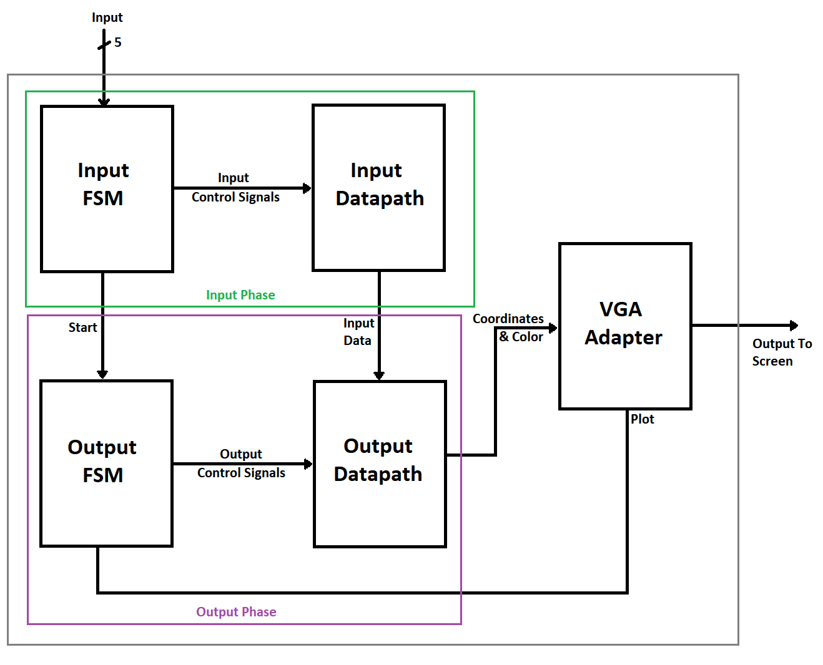

**Milestones:**

* **Week 1:** Complete Input Phase (Converting input from finger taps to character)
* **Week 2:** Complete Output Phase (Drawing character on screen and moving cursor)
* **Week 3:** Combine Input and Output Phase for project completion and (time permitting) add some extra features.